Assignment 6
Topic： Database Design & System Implementation Date： Class：
Name： StudentID： Score：

- Convert the following class diagram to Java code.
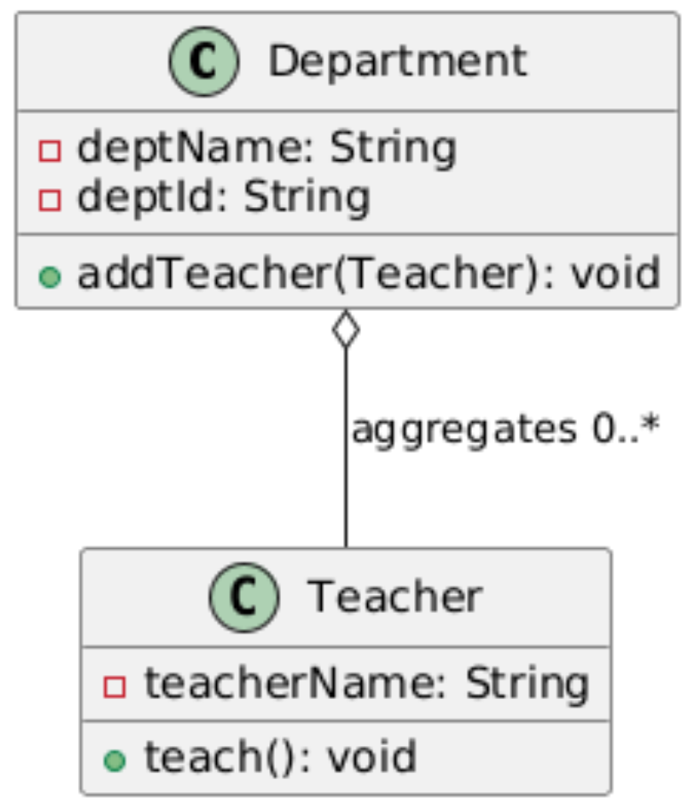

- A student score management system has unreasonable database design: a single student table contains a large number of redundant course and score fields, resulting in difficult data modification and update anomalies.
SID | CID | CName | SCORE | SName
20230001 | C001 | Math | 89 | Jerry
20230002 | C002 | Chinese | 90 | Tom
20230002 | C002 | Math | 94 | Spark
(1) Analyze the data redundancy and database design defects.
(2) Complete the E-R conceptual design of student-course-score relationship.
(3) Convert the E-R model into standard relational tables and explain the optimization idea of eliminating redundant data.

